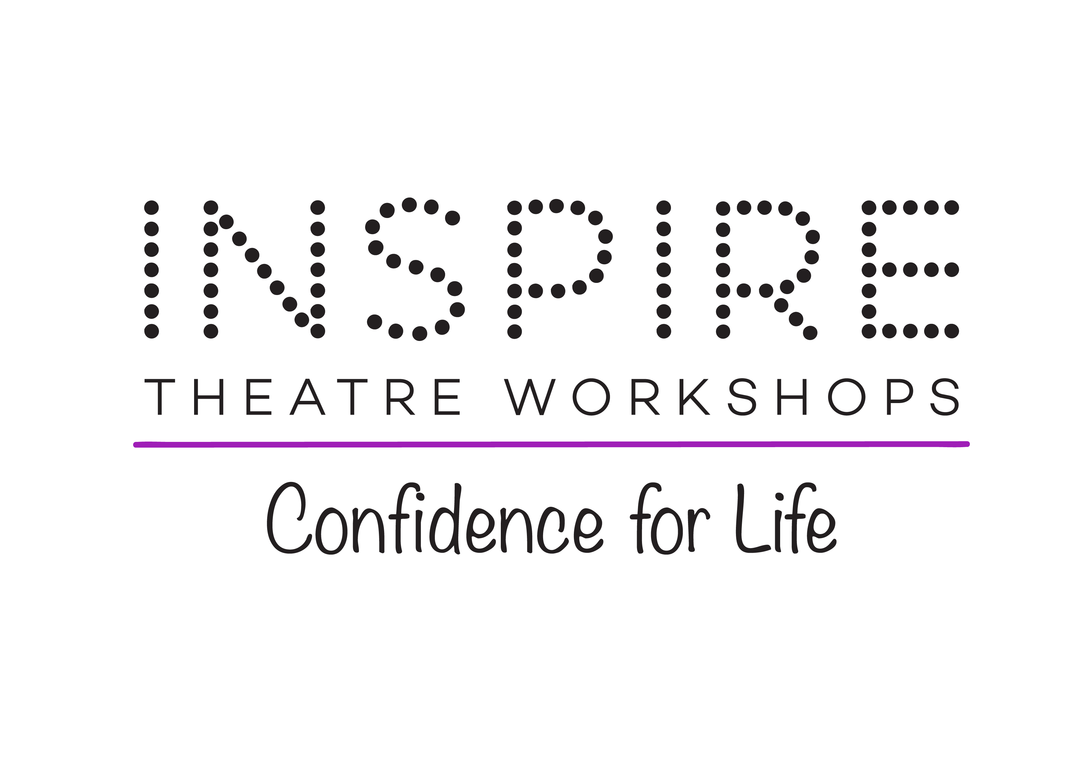

Staying COVID-19 Secure in 2020 Risk Assessment

Coronavirus (COVID-19): implementing protective measures in Dance and Drama settings

Name of School: Inspire Theatre Workshops Ltd

Name of Manager/Owner: Jennifer Macdonell

Postcode of premises: RM14 2PH

Disciplines offered: Group Dance - Modern, Group Dance - Jazz, Group Dance - Street & HipHop, Group Drama (Play-Based), Group Drama (Musical Theatre Based), Individual Drama Lessons (ie LAMDA), Group Singing, Individual Singing Lessons

Ages: 3-5yrs, 6-10yrs, 11-13yrs

Intended start date (based on continuing guidance): October 2020

Risk Assessment written by Alex Ralls (AIIRSM, TechIOSH) based on information provided.
Dated: Friday, 2 October 2020
Risk Assessment implemented by Jennifer Macdonell

Introduction

In all education, childcare and social care settings, preventing the spread of Coronavirus involves dealing with direct transmission (for instance, when in close contact with those sneezing and coughing) and indirect transmission (via touching contaminated surfaces). A range of approaches and actions should be employed to do this. These can be seen as a hierarchy of controls that, when implemented, creates an inherently safer system, where the risk of transmission of infection is substantially reduced.

This Risk Assessment was undertaken based on information provided by Jennifer Macdonell on behalf of Inspire Theatre Workshops Ltd.

The possibility of delivering all/some classes virtually (using TEAMS or Zoom for example) has been considered and whilst some classes can continue to be delivered virtually the nature of the Dance and Drama business requires physical presence, where possible, to ensure technique is properly managed to prevent injury. Physical contact will be limited, or managed, in line with the control measures outlined in this document and Government guidance on ‘Social Distancing’.

Any change resulting in the escalation of either the Severity Rating or Probability Rating of an identified hazard is to be reported to Jennifer Macdonell or an appropriate line manager at Inspire Theatre Workshops Ltd. The severity and probability definitions relating to this document can be found below.

It is assumed that this Risk Assessment forms part of Inspire Theatre Workshops Ltd’s over-arching Risk Assessments, Operating Procedures and preventative measures used to minimise risk. It should not be viewed in isolation. Other documentation that should be considered, where applicable, includes;
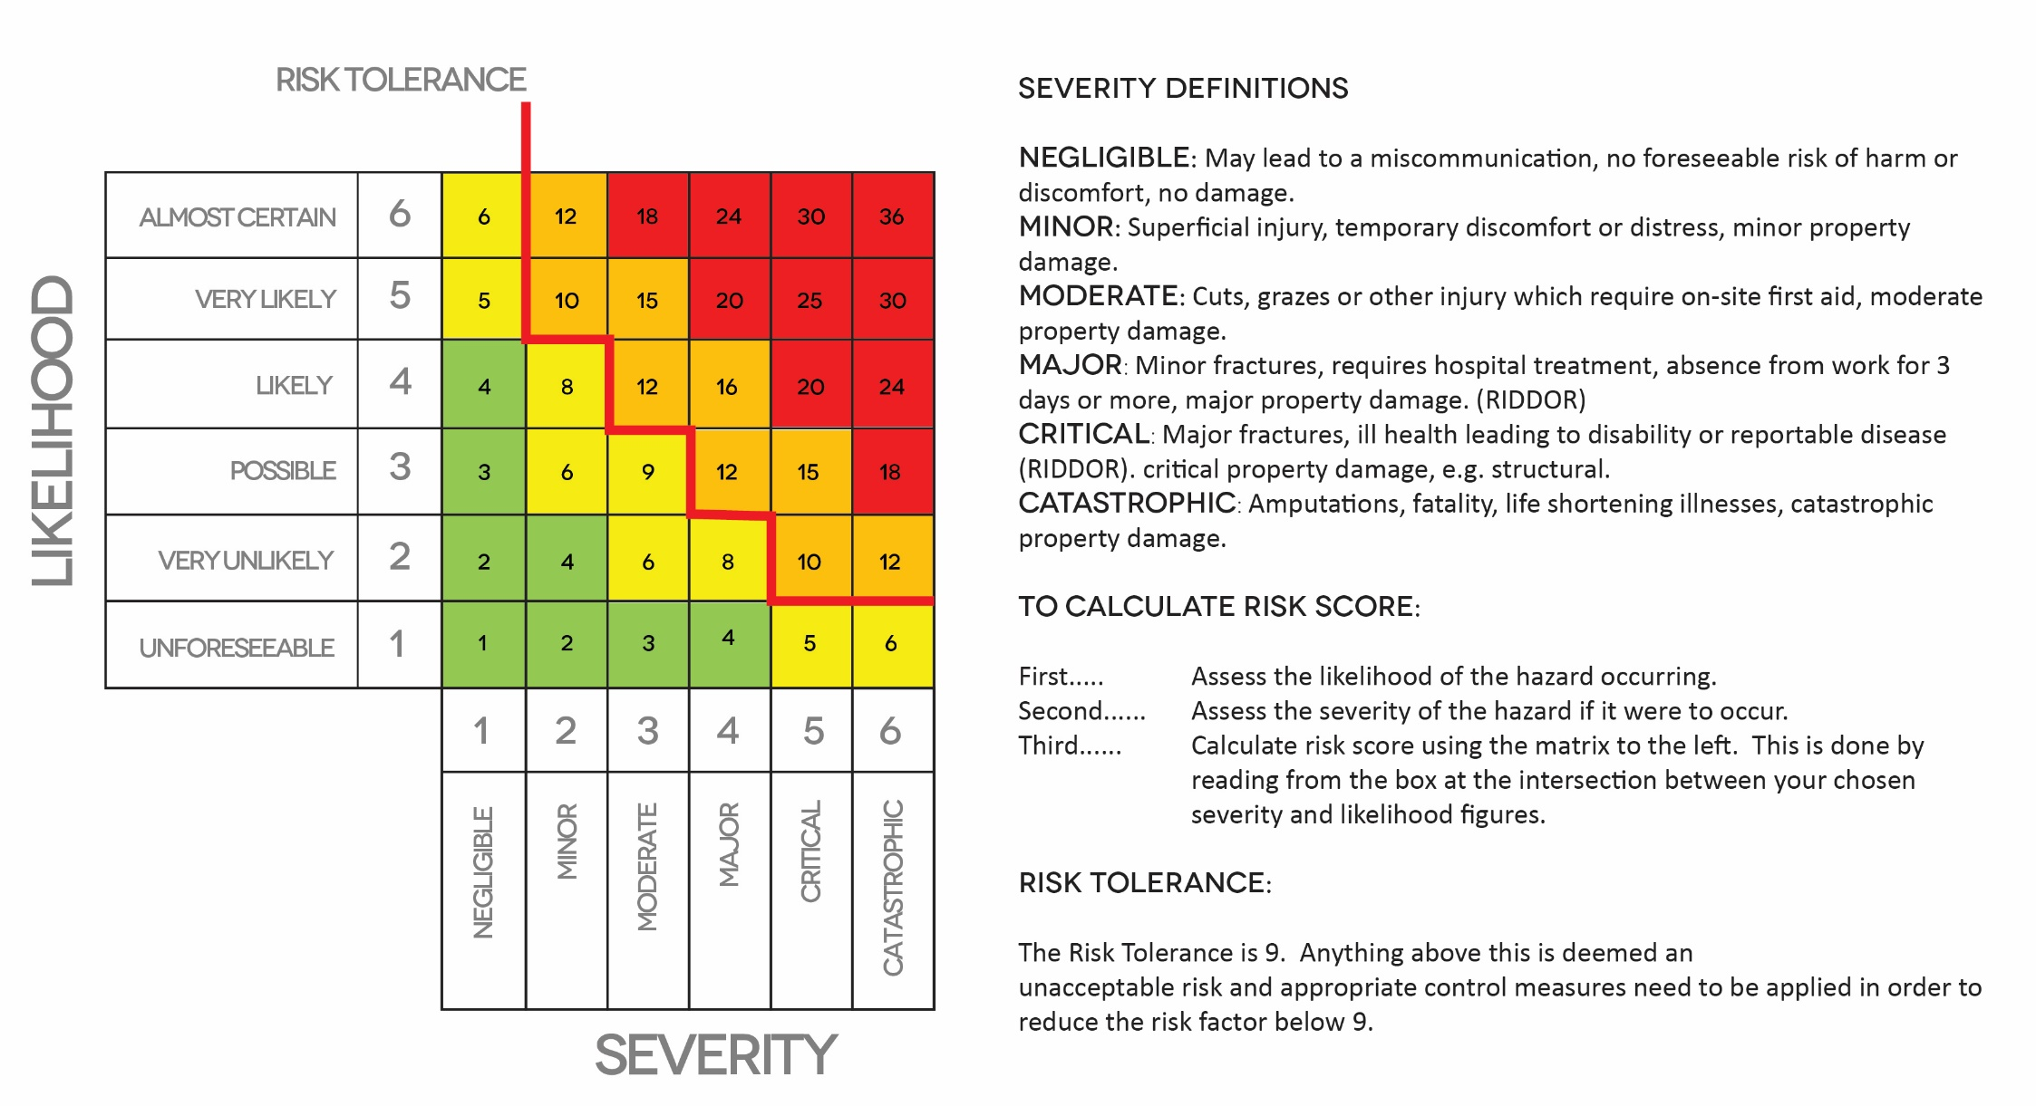
https://www.gov.scot/collections/coronavirus-covid-19-guidance/
School Risk Assessments
School Operating Procedures
School Method Statements
Child Protection Policy
Space/Venue Handbook and RAMS

General – Staff and Student Welfare (prior to attendance)
Hazard | Risk | Who is at Risk | Likelihood | Severity | Risk Score | Control Measure | Likelihood | Severity | Risk Score
Exposure from others due to:  1) Living with someone with a confirmed case of COVID-19.  2) Have come into close contact (within 2 metres for 15 minutes or more) with a confirmed case of COVID-19.  3) Being advised by a public health agency that contact with a diagnosed case has occurred. | Contracting and/or conveying COVID-19 | All | 4 | 4 | 16 | - If instructed under ‘Test and Protect’ to follow government action of self-isolation and only to leave house on the following circumstances: for medical reason; to shop for necessary food supplies; for exercise once per day; and for essential works including those deemed ‘key workers’  - To continue following ongoing government guidance https://www.gov.scot/coronavirus-covid-19/  - Where an employee to maintain contact with the Head of College and to follow College policy and guidance.  - Stay at home and only attend hospital in an emergency. Do not attend GP surgery and phone NHS 24 line (111) if further advice is required  - Follow good NHS hygiene measures at all times  - Avoid all visitors to your home unless they are providing a medical requirement  - Do not approach delivery staff, allow packages to be left on the doorstep  - Do not take any antibiotics as they do not work against viruses.  - Where the child, young person or staff member tests positive, the rest of their class or group within their school setting should be sent home and advised to self-isolate for 14 days. The other household members of that wider class or group do not need to self-isolate unless the child, young person or staff member they live with in that group subsequently develops symptoms.  - Continue to offer classes virtually where possible in order that self-isolated students can continue to participate – thereby encouraging parents and students to ‘do the right thing’ and follow current advice. | 2 | 4 | 8
Persons classified as vulnerable | Contracting and/or conveying COVID-19 | Vulnerable persons | 3 | 6 | 18 | - To ensure extremely vulnerable persons  - Solid organ transplant recipients.  - People with specific cancers:  - people with cancer who are undergoing active chemotherapy  - people with lung cancer who are undergoing radical radiotherapy  - people with cancers of the blood or bone marrow such as leukaemia, lymphoma or myeloma who are at any stage of treatment  - people having immunotherapy or other continuing antibody treatments for cancer  - people having other targeted cancer treatments which can affect the immune system, such as protein kinase inhibitors or PARP inhibitors  - people who have had bone marrow or stem cell transplants in the last 6 months, or who are still taking immunosuppression drugs  - People with severe respiratory conditions including all cystic fibrosis, severe asthma and severe chronic obstructive pulmonary disease (COPD).  - People with rare diseases that significantly increase the risk of infections (such as severe combined immunodeficiency (SCID), homozygous sickle cell).  - People on immunosuppression therapies sufficient to significantly increase risk of infection.  - Women who are pregnant with significant heart disease, congenital or acquired.  - Other people have also been classed as clinically extremely vulnerable, based on clinical judgement and an assessment of their needs. GPs and hospital clinicians have been provided with guidance to support these decisions.  are following current advice https://www.gov.uk/government/publications/guidance-on-shielding-and-protecting-extremely-vulnerable-persons-from-covid-19/guidance-on-shielding-and-protecting-extremely-vulnerable-persons-from-covid-19  - Managers should stay in touch with vulnerable or extremely vulnerable staff who are staying at home by phone to ensure they are well and to prevent them from feeling isolated | 2 | 5 | 10
Staff or students with individual Risk Assessments (i.e. disability, young persons or new/expectant mothers) | Contracting and/or conveying COVID-19 | Identified individual | 3 | 4 | 12 | - Existing individual Risk Assessments have been reviewed as necessary and additional measures put in place for those at enhanced risk of contracting and/or conveying COVID-19.  - Where it isn’t possible to ensure adequate protection for a vulnerable member of staff, they have been advised not to attend work and to remain on Furlough (where this is possible).  - Where it isn’t possible to ensure adequate protection for a vulnerable student, they have been advised not to attend class. | 2 | 4 | 8
General – Staff and Student Travel to/from School
Hazard | Risk | Who is at Risk | Likelihood | Severity | Risk Score | Control Measure | Likelihood | Severity | Risk Score
Exposure to COVID-19 due to use of public transport and/or shared family transport | Contracting and/or conveying COVID-19 | All | 4 | 4 | 16 | - All persons to limit their use of public transport to/from class. Where travel is essential to use private dual occupancy where possible.  - Reduce the amount of time using public transport and to implement social distancing where possible (2m clearance from persons and not to travel in groups of more than 2 unless it is immediate family)  - Encourage staff, parents, children and young people to walk or cycle to their classes where possible  - Ensure staff, parents, children and young people follow the Coronavirus (COVID-19): safer travel guidance for passengers when planning their travel. | 2 | 4 | 8
Exposure to COVID-19 due to failing to plan parking and drop off measures | Contracting and/or conveying COVID-19 | All | 4 | 4 | 16 | - Plan parents’ drop-off and pick-up protocols that minimise adult to adult contact  - Parents of children are to park and walk their child to the entrance to be handed over to a member of staff (remaining 2m from other families).  - Tell parents that if the child needs to be accompanied to their classes, only one parent should attend  - Tell parents and young people their allocated drop off and collection times and the process for doing so, including protocols for minimising adult to adult contact (for example, which entrance to use)  - Make it clear to parents that they cannot gather at studio door, or enter the site (unless they have a pre-arranged appointment, which should be conducted safely)  - Verbal confirmation will be sought from parent or carer of 3-7yr olds that they have not been displaying any signs or symptoms of COVID-19. Older students will be asked for verbal confirmation on arrival that they feel well. | 2 | 4 | 8

Staff Training
Hazard | Risk | Who is at Risk | Likelihood | Severity | Risk Score | Control Measure | Likelihood | Severity | Risk Score
Teaching and coaching staff failing to act appropriately (infection control) | Contracting and/or conveying COVID-19 | All | 3 | 4 | 12 | - All staff have received training in the signs and symptoms of COVID-19  - Staff have been consulted and informed about the plans (for example, safety measures, reporting requirements, timetable changes and staggered arrival and departure times), including discussing whether additional training would be helpful.  - Staff have been spoken to about correction methods (where these would normally be done with considered physical contact) and delivering guidance at a distance | 1 | 4 | 4
Venue, support staff, and delivery workers failing to act appropriately (infection control) | Contracting and/or conveying COVID-19 | All | 3 | 4 | 12 | - Communicate early with venue, contractors and suppliers that will need to prepare to support your plans for opening for example, cleaning, catering, food suppliers and hygiene suppliers  - Discuss with cleaning contractors or staff the additional cleaning requirements and agree additional hours to allow for this. | 1 | 4 | 4
Venue – Spaces/Studios
Hazard | Risk | Who is at Risk | Likelihood | Severity | Risk Score | Control Measure | Likelihood | Severity | Risk Score
Ingress/Egress to site leading to lack of infection control | Contracting and/or conveying COVID-19 | All | 3 | 4 | 12 | - Where possible to implement the following practices:  - Stop all non-essential visitors (includes parents, carers and visiting tutors where the skill can be delivered ‘in house’)  - Introduce staggered class start and finish times to reduce congestion and contact at all times  - Monitor site access points to enable social distancing – you may need to change the number of access points, either increase to reduce congestion or decrease to enable monitoring  - Consider one-way circulation, or place a divider down the middle of the corridor to keep groups apart as they move through the setting where spaces are accessed by corridors  - Prop doors open, where safe to do so (bearing in mind fire safety and safeguarding), to limit use of door handles and aid ventilation  - Require all staff and students to wash their hands for 20 secs or clean with anti-bacterial gel before entering or leaving the space  - Allow plenty of space (two metres) between people waiting to enter studio(s)  - Regularly clean common contact surfaces in reception, offices and studios (such as drama blocks, pianos, chairs and barres), particularly during peak flow times  - Whilst in general groups should be kept apart, brief, transitory contact where unavoidable, such as passing in a corridor, is low risk. | 2 | 4 | 8
Inadequate cleaning of space(s) | Contracting and/or conveying COVID-19 | All | 3 | 4 | 12 | - Follow the COVID-19: cleaning of non-healthcare settings guidance  - Regularly clean common contact surfaces in reception, offices and studios (such as drama blocks, pianos, chairs and barres), particularly during peak flow times  - Cleaning frequently touched surfaces using standard products, such as detergents and bleach  - Remove unnecessary items from studio environments where there is space to store it elsewhere  - Remove soft furnishings and any items that are hard to clean (such as gym mats, props or those with intricate parts)  - Ensure adequate cleaning between groups is in place, following the COVID-19: cleaning of non-healthcare settings guidance | 2 | 4 | 8
Lack of ventilation of space(s) | Contracting and/or conveying COVID-19 | All | 3 | 4 | 12 | - Where possible, all spaces should be well ventilated using natural ventilation (opening windows).  - Increase ventilation (to ideally maximum) within enclosed spaces and ensure air handling systems are not occupancy driven (over-ride where possible).  - Prop doors open, where safe to do so (bearing in mind fire safety and safeguarding), to limit use of door handles and aid ventilation. | 2 | 4 | 8
Lack of Hand Washing | Contracting and/or conveying COVID-19 | All | 3 | 4 | 12 | - Staff and students to frequently wash their hands with soap and warm water for 20 seconds and dry thoroughly (ideally every 60mins). Review the guidance on hand cleaning  - Staff and students to clean their hands on arrival at the school  - Ensure help is available for children and young people who have trouble cleaning their hands independently  - Consider how to encourage young children to learn and practise these habits through drama games, songs and repetition. | 2 | 4 | 8
Lack of provision of effective Hand Gel | Contracting and/or conveying COVID-19 | All | 2 | 4 | 8 | - Ensure that hand gel (minimum 60% ethanol or 70% isopropanol) is available where hand-washing facilities are not readily accessible.  - Staff and students to clean their hands with hand gel on arrival at the school entrance | 1 | 4 | 4
Toilet facilities – high risk contact areas | Contracting and/or conveying COVID-19 | All | 3 | 4 | 12 | - Ensure that toilets do not become crowded by limiting the number of staff or students who use the toilet facilities at one time.  - Dedicate a toilet for use by Dance and Drama students where facilities are accessed by other persons such as members of the public and venue staff – consider Child Protection implications.  - Display signage to the above effect. | 2 | 4 | 8
Failure of Respiratory hygiene | Contracting and/or conveying COVID-19 | All | 3 | 4 | 12 | - Avoiding touching your face/eyes/nose/mouth with unwashed hands and cover your cough or sneeze with a tissue then throw it in the bin (‘catch it, bin it, kill it’).  - Monitoring of younger students to ensure they follow the above.  - Provision of sufficient bins and waste receptacles around the school/studio(s)  - Provision of boxes of tissues around the school/studio(s) | 2 | 4 | 8
Lack of signage leading to a failure to follow guidance | Contracting and/or conveying COVID-19 | All | 3 | 4 | 12 | - Display the following, where appropriate, around the school and studios;  - Catch It, Bin It, Kill It  - Social Distancing  - Use Hand Gel  - Please Wash Your Hands For 20 Sec  - Your Nearest Sanitisation Point Is  - Hand Sanitisation Point Right Arrow  - Hand Sanitisation Point  - Hand Sanitisation Point Left Arrow  - No Entry  - Downstairs Only  - Up Stairs Only  - Maximum Occupancy of <insert> People | 2 | 4 | 8
Ill student, child or member of staff | Contracting and/or conveying COVID-19 | All | 4 | 4 | 16 | - If a student or child is awaiting collection, they should be moved, if possible, to a room where they can be isolated behind a closed door, depending on the age of the child and with appropriate adult supervision if required. Ideally, a window should be opened for ventilation. If it is not possible to isolate them, move them to an area which is at least 2 metres away from other people.  - If they need to go to the bathroom while waiting to be collected, they should use a separate bathroom if possible. The bathroom should be cleaned and disinfected using standard cleaning products before being used by anyone else.  - If a child or student becomes unwell with symptoms of coronavirus while in their class and needs direct personal care until they can return home a fluid-resistant surgical face mask should be worn by the supervising adult if a distance of 2 metres cannot be maintained. If contact with the child or young person is necessary, then disposable gloves, a disposable apron and a fluid-resistant surgical face mask should be worn by the supervising adult. If a dynamic risk assessment determines that there is a risk of splashing to the eyes, for example from coughing, spitting, or vomiting, then eye protection should also be worn. | 2 | 4 | 8
Lack of provision of First Aid or failing to consider implications on first aid and medical provision. | Contracting and/or conveying COVID-19 | All | 3 | 3 | 9 | - Consider if it is appropriate to increase first aid provision whilst the Coronavirus (COVID-19) risk is present.  - Consider the scheduling of higher risk activities and potential demands on emergency services.  - First aid boxes should be checked regularly to make sure that they are fully stocked and, where possible, they should include resuscitation face shields.  - First aiders should all be briefed to check the latest Government guidance on cardiopulmonary resuscitation - https://www.gov.uk/government/publications/novel-coronavirus-2019-ncov-interim-guidance-for-first-responders/interim-guidance-for-first-responders-and-others-in-close-contact-with-symptomatic-people-with-potential-2019-ncov | 1 | 3 | 3
Lack of Waste Management | Contracting and/or conveying COVID-19 | All | 2 | 4 | 8 | - Ensure that bins for tissues are emptied throughout the day. | 1 | 4 | 4
Delivery of classes
Hazard | Risk | Who is at Risk | Likelihood | Severity | Risk Score | Control Measure | Likelihood | Severity | Risk Score
Class timetable- lack of planning | Contracting and/or conveying COVID-19 | All | 4 | 4 | 16 | - Decide which lessons or activities will be delivered (this may be a reduced timetable offering non-contact activities initially – i.e. Modern and individual dance lessons but not Pas De Deux, individual LAMDA exam preparation but not Musicals)  - Reduce and control any activities that result in air droplets travelling excessive distance (i.e. Vocal Projection, Singing and Breathing exercises).  - Where such activities are introduced in line with guidance introduce further controls such as;  - Individual lessons  - Smaller group sizes  - Group lessons delivered in one direction with minimum distancing rather than in a circle  - Increase distance between the vocalist and piano/teacher beyond 2m  - Refer to Devolved and Local guidance regards singing  - Consider if any activities could take place outdoors (such as Street Dance, open-air drama/plays)  - Use the timetable to reduce movement around the school/studio(s)  - Consider how to keep small groups of students together throughout the day and to avoid larger groups of students mixing  - Ensure that students are in the same small groups at all times each day, and different groups are not mixed during the day, or on subsequent days. (This may mean that a student may not undertake all of the classes they would normally wish to).  - Ensure that the same teacher(s) and other staff are assigned to each group and, as far as possible, these stay the same during the day and on subsequent days, recognising that there will be some subject specialist rotation of staff (for example Singing teachers).  - Refer to Government guidance relevant to schools where appropriate https://www.gov.scot/binaries/content/documents/govscot/publications/advice-and-guidance/2020/07/coronavirus-covid-19-guidance-preparing-start-new-school-term-august-2020/documents/coronavirus-covid-19-guidance-preparing-start-new-school-term-august-2020/coronavirus-covid-19-guidance-preparing-start-new-school-term-august-2020/govscot%3Adocument/coronavirus-covid-19-guidance-preparing-start-new-school-term-august-2020.pdf | 2 | 4 | 8
Excess class capacity resulting in ineffective social distancing | Contracting and/or conveying COVID-19 | All | 3 | 4 | 12 | - Where operating socially distanced classes limit studio capacities to:  Low intensity* High Intensity^  Studio 1 13 11  Please visit the following link to ensure your capacities are up to date:  http://www.alexralls.co.uk/capacity-calculator/  - Where operating as ‘bubbles’ comply with Sports Scotland guidance regarding capacities https://sportscotland.org.uk/media/5960/scottish-gymnastics-covid-19-route-map-phase-32-guidance.pdf if lower than capacities outlined above.  - Classes to be delivered by one person or as small number of persons as possible without compromising safety or child protection measures.  - Phased increasing of class numbers to take place to ensure that policies and procedures are robust. To run ‘tester’ classes with maximum of 6 students initially and slowly increase to the maximum outlined above.  - Mark up the space/studio(s) with tape to maintain adequate distance in line with current guidance.  - NOTE on the 23rd June social distancing guidance was revised to be 1m+ ONLY with mitigating controls AND where a distance of 2m cannot be achieved. As further guidance is released for studio-based activities capacities may be updated in compliance with latest guidance. | 2 | 4 | 8
Concurrent class start and finish times resulting in ineffective social distancing | Contracting and/or conveying COVID-19 | All | 3 | 4 | 12 | - Introduce staggered start and finish times to reduce congestion and contact at all times. | 2 | 4 | 8
Use of sound systems and live music | Contracting and/or conveying COVID-19 | All | 4 | 4 | 16 | - Encourage using Bluetooth to play music from the sound system in order to minimise contact with studio equipment  - Sound equipment should be cleaned before and after use with an anti-viral wipe  - Consider the volume of music. The louder the music, the louder the instructor will have to project, potentially causing droplets to travel further  - Live musicians (such as Ballet Pianists) should be assigned to a consistent studio since disinfecting instruments (such as pianos) may be difficult. | 2 | 4 | 8
Overuse or unnecessary use of Changing facilities | Contracting and/or conveying COVID-19 | All | 4 | 4 | 16 | - Students arrive for class ‘ready to go’ and as such minimise use of changing and toilet facilities. | 2 | 4 | 8
Warm up and physical activities requiring contact with the studio floor | Contracting and/or conveying COVID-19 | All | 4 | 4 | 16 | - All students should wear appropriate shoes for all Classes – no bare feet  - Floors and any other areas touched by anyone should be cleaned before the next class at a minimum.  - Across the Floor  - Students should avoid following right behind each other; it is safer to work next to each other. If dancers travel directly behind each other, they are in the slipstream where droplets remain suspended. To avoid contact, students need to allow even further distance.  - Students should maintain 2 metre distance apart standing side by side in one line and allow each group to complete the combination to the end of the room before the next group starts.  - Dancers should be reminded to maintain a distance of at least 2 metres when waiting to go across the floor and after completing the combination. | 2 | 4 | 8
Partner work | Contracting and/or conveying COVID-19 | All | 4 | 4 | 16 | - Eliminate any 'partner' work for the immediate future.  - Limit the frequency of working within 2-metres to an absolute minimum and ensure it is for strictly low intensity, sporadic work where exposure to this distance is less than 15 mins.  NB – partner work involving students from the same household (if applicable) is permitted. | 2 | 4 | 8
Shared equipment (i.e. Props, Acro equipment, Ballet Barres etc) | Contracting and/or conveying COVID-19 | All | 3 | 4 | 12 | - Seek to prevent the sharing of equipment where possible. Where this isn’t possible shared equipment and surfaces should be cleaned and disinfected more frequently as per the above. | 2 | 4 | 8

Personal protective equipment (PPE) including face coverings and facemasks
Wearing a face covering or face mask in schools or other education settings is not recommended. Face coverings may be beneficial for short periods indoors where there is a risk of close social contact with people you do not usually meet and where social distancing and other measures cannot be maintained, for example on public transport or in some shops. This does not apply to schools or other education settings. Schools and other education or childcare settings should therefore not require staff, children and learners to wear face coverings. Changing habits, cleaning and hygiene are effective measures in controlling the spread of the virus. Face coverings (or any form of medical mask where instructed to be used for specific clinical reasons) should not be worn in any circumstance by those who may not be able to handle them as directed (for example, young children, or those with special educational needs or disabilities) as it may inadvertently increase the risk of transmission.
The majority of staff in education settings will not require PPE beyond what they would normally need for their work, even if they are not always able to maintain a distance of 2 metres from others. PPE is only needed in a very small number of cases including:
- children, young people and students whose care routinely already involves the use of PPE due to their intimate care needs should continue to receive their care in the same way
- if a child, young person or other learner becomes unwell with symptoms of coronavirus while in their setting and needs direct personal care until they can return home. A fluid-resistant surgical face mask should be worn by the supervising adult if a distance of 2 metres cannot be maintained. If contact with the child or young person is necessary, then disposable gloves, a disposable apron and a fluid-resistant surgical face mask should be worn by the supervising adult. If a risk assessment determines that there is a risk of splashing to the eyes, for example from coughing, spitting, or vomiting, then eye protection should also be worn

* Capacity for low impact work (i.e where the respiratory rate remains relatively normal e.g drama and low impact dance work)
^Capacity for high impact work (i.e where the respiratory rate is increased beyond normal)

Face Coverings

Refer to https://www.gov.scot/binaries/content/documents/govscot/publications/advice-and-guidance/2020/07/coronavirus-covid-19-guidance-preparing-start-new-school-term-august-2020/documents/coronavirus-covid-19-guidance-preparing-start-new-school-term-august-2020/coronavirus-covid-19-guidance-preparing-start-new-school-term-august-2020/govscot%3Adocument/coronavirus-covid-19-guidance-preparing-start-new-school-term-august-2020.pdf for current advice regards face coverings

